**WHAT DOES THE COMPANIONS ONLINE LOOK LIKE?**

Companions Online is an opportunity to become “monastics in the world,” living a Benedictine rhythm of prayer, work, study, and recreation. Online Companions learn to develop practices that support and nurture their spiritual life from the comfort of their homes.

Classes explore the images of God, how to pray, growth in self-knowledge, how personality shapes our spiritual life, the monastic tradition that has given shape to Christian culture through the centuries, and new forms of contemplative and communal life.

Online Companions meet regularly for classes and discussion groups, and commit to times of personal prayer at home. They share in book studies, participate in online worship, and screen films relevant to spiritual growth and self-understanding. Online Companions will develop spiritual disciplines following the liturgical year, plumbing the richness that the rhythms of each season offer.

For more information, or to apply, please contact:

Shannon Epp, Companions Coordinator at

Email: [companions@ssjd.ca](mailto:companions@ssjd.ca)

Phone: 416-226-2201, Ext. 342



**Applications for the next Companions Program**

***Start: January 1, 2026***

***End: May 1, 2026***

In choosing Companions, we strive for a balance of background and experience necessary for effective group interaction and community building. *Applicants will be notified by the end of July 2026 if they have been accepted.*

[www.ssjd.ca](http://www.ssjd.ca)

[www.facebook.com/ssjdcanada](http://www.facebook.com/ssjdcanada)

The Companions Online Program

___________

Spending a Year Discovering God’s Rhythm

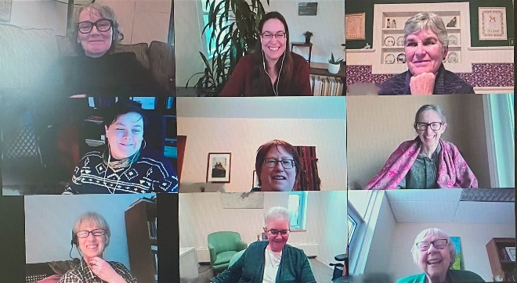____________

A ten-month online program for women who are seeking, discerning, and desiring a closer relationship with God and others.

____________________________________

**September 2026- June 2027**

____________________________________

**WHO IS THE PROGRAM FOR?**

For women of all Christian expressions who are seeking, discerning or desiring to enter into a deeper relationship and walk with God and others in a community setting.

Companions:

* Cultivate an appreciation for counter- cultural values, while growing in peace and freedom
* Deepen their rootedness and spiritual intimacy with God and other in community
* Discover a personal path to spiritual growth and transformation and discern their gifts and vocation

**GOALS OF THE PROGRAM:**

The program assists women to discern where God may be calling them by:

* Learning to cultivate a balanced life of prayer, service, study, rest and recreation.
* Engaging in classes and discussions about Christian life and vocation.
* Receiving personal guidance in deepening their prayer life.

**PROGRAM COST:**

$ 50.00/month is suggested toward expense.

If cost is a hindrance, please contact the Companions coordinator. Financial assistance is available.



**CLASSES INCLUDE:**

~ Explorations into images of God  
  
 ~ Contemplative and Benedictine Prayer  
  
 ~ The Rule of St. Benedict  
  
 ~ Growth in self-knowledge personality shapes our spiritual life  
  
 ~ The history of the monastic tradition and new forms of contemplative and communal life.  
  
 ~ Journaling and Awareness Reflection

**CRITERIA FOR ACCEPTANCE:**

Women who wish to apply should be:

* A practising Christian of any denomination
* Actively committed to discerning God's will in their life
* Desirous of deepening their relationship with God, a willingness to follow Jesus in his radical obedience and an openness to the leading of the Holy Spirit
* Able and willing to contribute to effective group processes. Is familiar with Zoom and has a stable internet connection.
* In good mental and emotional health.