**WHAT DOES A DAY LOOK LIKE?**

|  |  |
| --- | --- |
| Morning: | Individual quiet time  Breakfast  Morning prayer together  Class time |
| Noon: | Eucharist  Dinner  Personal time (resting, walking, reading) |
| Afternoon: | Some manual work  Study time  Meeting with your mentor |
| Evening: | Evening Prayer together  Supper  Dishes and clean-up  Recreation  Compline (night prayer)  Quiet time |

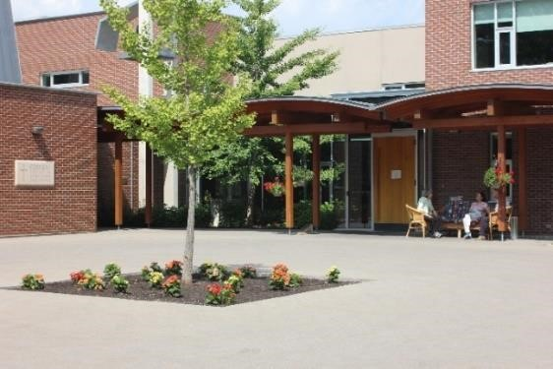

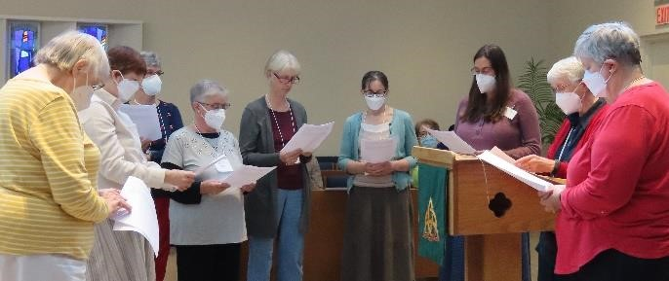

For more information, or to apply, please contact:

Shannon Epp, Companions Coordinator at

Email: companions@ssjd.ca

Phone: 416-226-2201, Ext. 342

**Applications for the 2026-2027 year:**

***Start: January 1, 2026***

***End: May 1, 2026***

In choosing Companions, we strive for a balance of background and experience necessary for effective group interaction and community building. *Applicants will be notified by the end of July 2026 if they have been accepted.*

[www.ssjd.ca](http://www.ssjd.ca/)

[www.facebook.com/ssjdcanada](http://www.facebook.com/ssjdcanada)

The Companions Residential Program

___________

Spending a Year Discovering God’s

Rhythm

____________



A ten-month residential program for women who are seeking, discerning, and

desiring a closer relationship with God and others.

____________________________________

**September 2026- June 2027**

____________________________________



**WHO IS THE PROGRAM FOR?**

For women who are seeking, discerning or desiring to enter into a deeper relationship and walk with God and others in a community setting.

Companions:

 Cultivate an appreciation for counter- cultural values, while

growing in peace and freedom

 Deepen their rootedness and spiritual intimacy with God and

other in community

 Discover a personal path to spiritual growth and transformation and

discern their gifts and vocation

**GOALS OF THE PROGRAM:**

The program assists women to discern where God may be calling them by:

 Sharing the life of a Christian community committed to a balanced life of prayer, service, study, rest and recreation.

 Engaging in classes and discussions about Christian life and vocation.

 Receiving personal guidance in deepening their prayer life.

**PROGRAM COST:**

$100.00/month is suggested toward expense.

Companions live at the convent and share the same free time, retreat opportunities and vacation as the Sisters do.

To benefit most fully from the program, Companions need to commit to staying the full time. If cost is a hindrance, please contact the Companions coordinator.

Financial assistance is available.

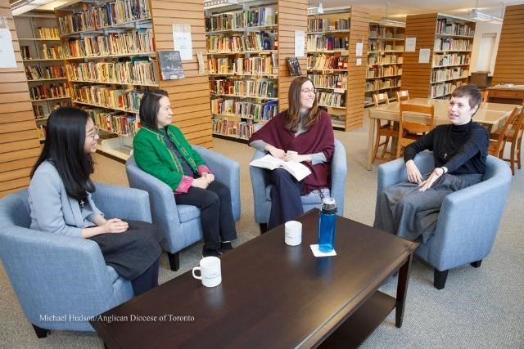

**CLASSES INCLUDE:**

~ Vocation and Discernment   
 ~ Contemplative and Benedictine Prayer   
 ~ Journaling and Awareness Reflection



**CRITERIA FOR ACCEPTANCE:**

Women who wish to apply should be:

 A practising Christian of any denomination

 Actively committed to discerning

God's will in their life

 Desirous of deepening their relationship with God, a willingness to follow Jesus in his radical obedience and an openness to the

leading of the Holy Spirit

 Able and willing to contribute to effective group processes and to live

in community;

 In good physical, mental and emotional health.