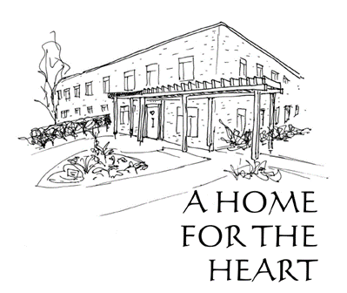
THE SISTERHOOD OF ST. JOHN THE DIVINE
CAMPAIGN DONATION FORM
“Thank you – what is that?” Po asked. “It means you are wonderful. It means, we couldn’t have done it without you,” said Liesl.
(from Liesl & Po by Lauren Oliver)

I/we wish to support the Home for the Heart Campaign with a donation of $__________.

CONTACT INFORMATION  Name(s) _____________________________________________  Address _____________________________________________  Postal Code __________________________________________  Phone ______________________________________________  Email _______________________________________________ | PAYMENT SCHEDULE  q Single payment $___________  q Monthly $________________  q Annually $________________  q Other $__________________  My/Our donation commences on  the ___ day of ____________, _______.
PAYMENT METHODS (please be sure that you designate Home for the Heart Campaign for all options, and indicate your name for an e-transfer.)
q Pre-authorized remittance (PAR) - please complete PAR form on reverse side or attached
q Credit Card payment - please fill out the information below
q E-transfer to email address: accounting@ssjd.ca, and include your address, phone number, email
q Cheque(s) (including post-dated) or cash
q Publicly traded securities , insurance policy, or other planned gifts—Please contact us for details
q Other: PayPal, Canada Helps - www.ssjd.ca/support-us/donate/
(Optional) I would like my gift to be in memory/honour of: _________________________________________.

CREDIT CARD PAYMENT DETAILS
Name on Card ____________________________________________
Card Number _________/ __________/ _________/________Expiry date __________ CVV _________
Signature ________________________________________________
Contact information: Fund Raising Office, email: fundraising@ssjd.ca or call (416) 226-2201 ext. 303.
Charitable no. BN 11925 4266 RR0001

