WHAT DOES A DAY LOOK LIKE?

Morning: Individual quiet time
Breakfast
Morning prayer together
Class time

Noon: Eucharist
Dinner
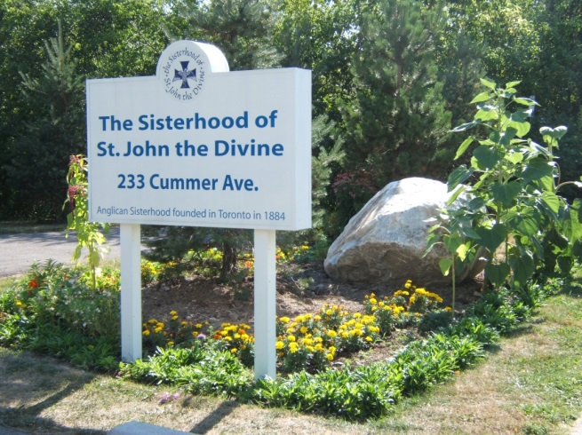
Personal time (resting,
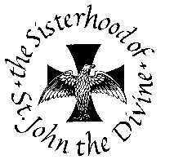
walking, reading)

Afternoon: Some manual work
Study time
Meeting with your mentor

Evening: Evening Prayer together
Supper
Dishes and clean-up
Recreation
Compline (night prayer)
Quiet time

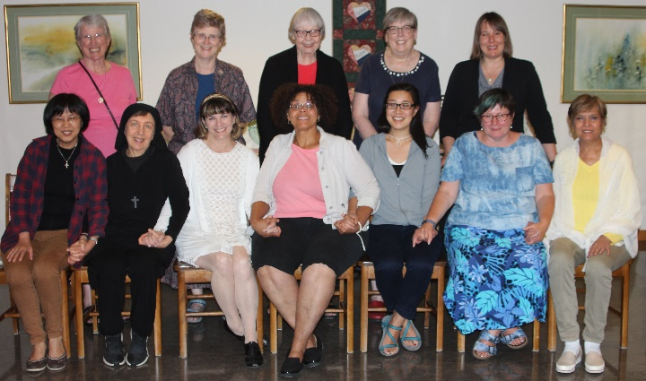
FOR FURTHER INFORMATION AND APPLICATION FORM, CONTACT:

Sr. Dorothy, SSJD, St. John's Convent
233 Cummer Avenue
Toronto, Ontario M2M 2E8
Phone: 416-226-2201, Ext. 301;
Fax: 416-226-2131
Email: convent@ssjd.ca

Deadline for all application material:
APRIL 10, 2023.

In choosing participants, we strive for a balance of background and experience necessary for effective group interaction and community building.

Applicants will be notified by April 25, 2023
If they have been accepted

For more information about SSJD please go to our website at www.ssjd.ca
AN OPPORTUNITY FOR

WOMEN AT A CROSSROADS

Sisterhood of St. John the Divine (Anglican)

July 7 – July 30, 2023

A residential program for women at a crossroads in career, study, or lifestyle.
This is what the LORD says: "Stand at the crossroads and look; ask for the ancient paths, ask where the good way is, and walk in it, and you will find rest for your souls.” (Jeremiah 6.16)
WHO IS THE PROGRAM FOR?

For women who are intentionally committed to seeking God's guidance in living out their baptismal call:

in business or professional careers,
in homemaking,
in lay careers in the church,
in volunteer work,
in missions at home & abroad,
in ordained ministry,
in monastic life,
or in the many other ways in which
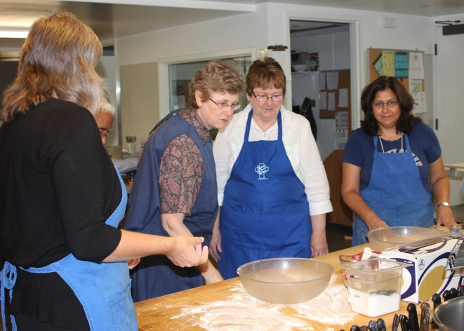
we may serve God.

GOALS OF THE PROGRAM

The program assists women to discern where God may be calling them, through:

- Sharing the life of a Christian community committed to a balanced life of prayer, service, study, rest and recreation.

- Engaging in classes and discussions about Christian life and vocation.

- Receiving personal guidance in deepening their prayer life.
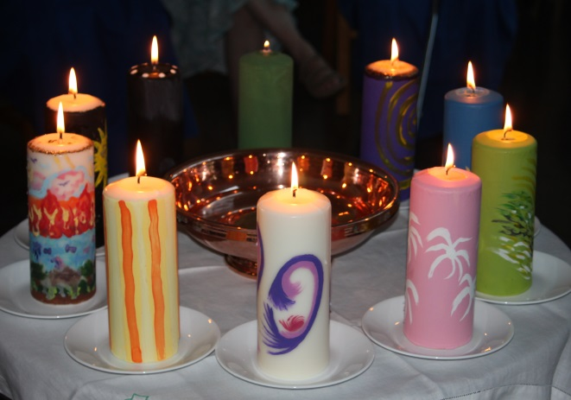
PROGRAM COST

There is no charge for room and board,
but participants contribute to the life of the community by sharing in the Sisters' work.

A tax deductible donation may be made to the Sisterhood but is not required.

To benefit most fully from the program, participants need to commit to staying the full time.

CLASSES INCLUDE

Vocation and Discernment
Contemplative Prayer
Journaling and Awareness Reflection
Prayer and Art
Prayer Walking and Labyrinth
Anglican Rosary

CRITERIA FOR ACCEPTANCE

A person who wishes to apply should be:

- a practising Christian of any denomination;

- actively committed to discerning God's will in her life;

- willing to give herself to a challenging schedule;

- able and willing to contribute to effective group processes;

- in good physical, mental and emotional health.

