WHAT DOES A DAY LOOK LIKE?

Morning: Individual quiet time
Breakfast
Morning prayer together
Class time

Noon: Eucharist
Dinner
Personal time (resting,
walking, reading)

Afternoon: Some manual work
Study time
Meeting with your mentor

Evening: Evening Prayer together
Supper
Dishes and clean-up
Recreation
Compline (night prayer)
Quiet time

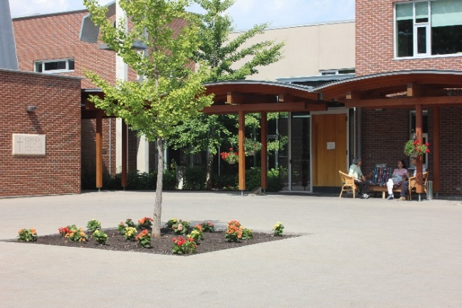
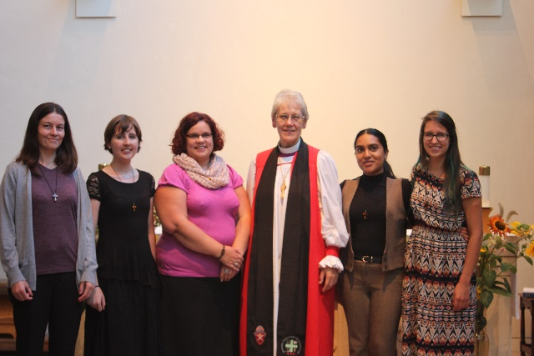

For more information, or to apply, please contact:

Shannon Frank-Epp, Companions Coordinator at
Email: companions@ssjd.ca
Phone: 416-226-2201, Ext. 342

Deadline for applications for the 2023-2024 year:

May 15, 2024.

In choosing Companions, we strive for a balance of background and experience necessary for effective group interaction and community building. Applicants will be notified by July 15, 2024 if they have been accepted.
www.ssjd.ca
www.facebook.com/ssjdcanada
www.twitter.com/ssjdcanada
The Companions Program
___________

Spending a Year Discovering God’s Rhythm
____________

An eleven- month residential program for women who are seeking, discerning, and desiring a closer relationship with God and others.
____________________________________

September 2023- June 2024.
____________________________________

WHO IS THE PROGRAM FOR?

For women who are seeking, discerning or desiring to enter into a deeper relationship and walk with God and others in a community setting.

Companions:
- Cultivate an appreciation for counter- cultural values, while growing in peace and freedom

- Deepen their rootedness and spiritual intimacy with God and other in community
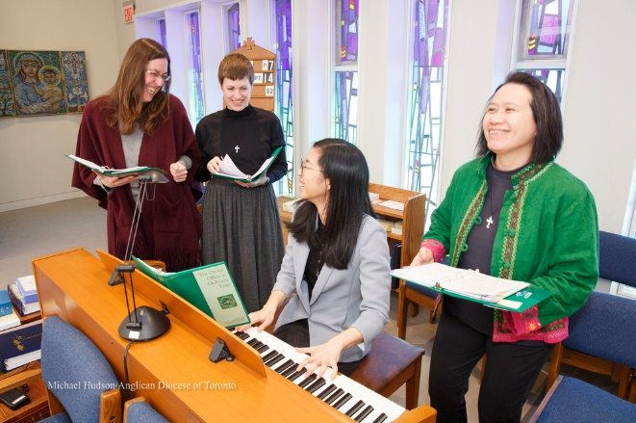
- Discover a personal path to spiritual growth and transformation and discern their gifts and vocation

GOALS OF THE PROGRAM:

The program assists women to discern where God may be calling them by:

- Sharing the life of a Christian community committed to a balanced life of prayer, service, study, rest and recreation.

- Engaging in classes and discussions about Christian life and vocation.

- Receiving personal guidance in deepening their prayer life.
PROGRAM COST:
$100.00/month is suggested toward expense.
Companions live at the convent and share the same free time, retreat opportunities and vacation as the Sisters do.

To benefit most fully from the program, Companions need to commit to staying the full time. If cost is a hindrance, please contact the Companions coordinator. Financial assistance is available.

CLASSES INCLUDE:
~ Vocation and Discernment
~ Contemplative and Benedictine Prayer
~ Journaling and Awareness Reflection

CRITERIA FOR ACCEPTANCE:

Women who wish to apply should be:

- A practising Christian of any denomination

- Actively committed to discerning God's will in their life

- Desirous of deepening their relationship with God, a willingness to follow Jesus in his radical obedience and an openness to the leading of the Holy Spirit

- Able and willing to contribute to effective group processes and to live in community;

- In good physical, mental and emotional health.

