Why I love to volunteer at the Convent

Volunteering here has opened me up to “less is more” and I’ve learned more about myself in the quiet.

It gives me insight into the life of women living in community and allowed me to witness the simplicity of the Sisters’ lifestyle.

The convent is an oasis in the midst of the outside world, a place with a healing atmosphere where I can gather my thoughts and nourish my spirit.

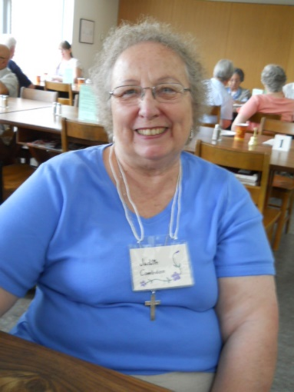
It strengthens my spiritual growth and gives me an opportunity to take part in the festivals and celebrations of the church
Calendar with the Sisters and their extended family.
For further information or to apply,
please contact:

St. John’s Convent
Sr. Beryl, Volunteer Coordinator
233 Cummer Avenue
Toronto, Ontario M2M 2E8

Phone: 416-226-2201
Fax: 416-222-4442
Email: volunteers@ssjd.ca

The Convent is easily accessible by public transit. For those driving, it is also close to highway 401. For more detailed directions and information about the Convent, please refer to our website or our social media accounts:
www.ssjd.ca
www.facebook.com/ssjdcanada
www.twitter.com/ssjdcanada
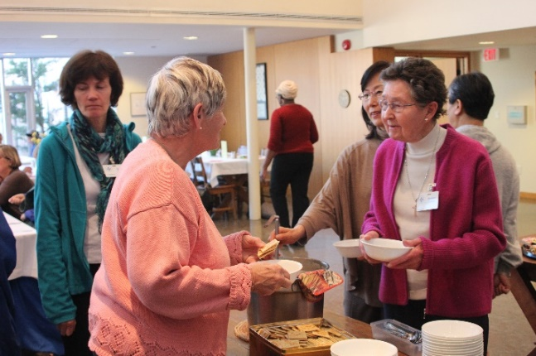
“Now there are varieties of gifts, but the same Spirit; and there are varieties of services, but the same Lord; and there are varieties of activities, but it is the same God who activates all of them in everyone. To each is given the manifestation of the Spirit for the common good.”
(1 Corinthians 12.4-7)
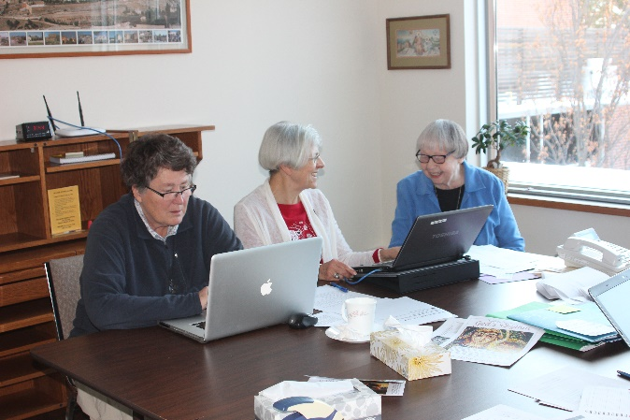
VOLUNTEER OPPORTUNITIES
at
St. John’s Convent
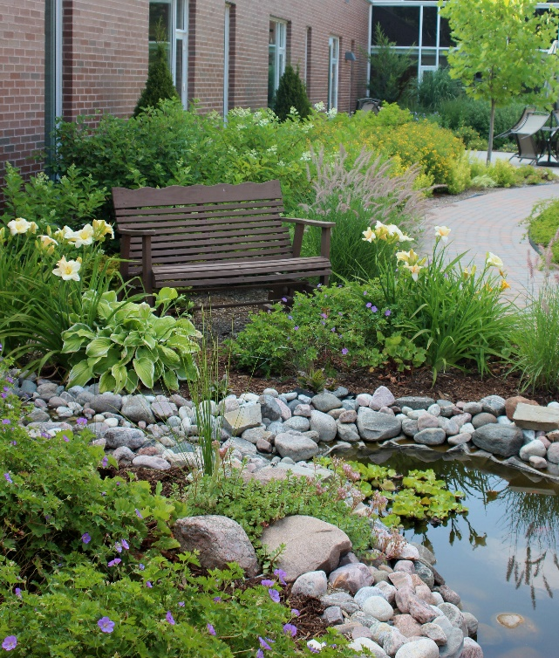
The Anglican Convent of St. John the Divine
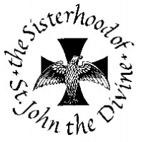
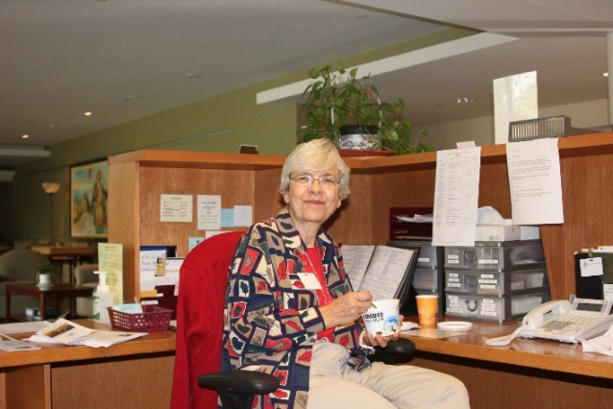
About the Sisterhood

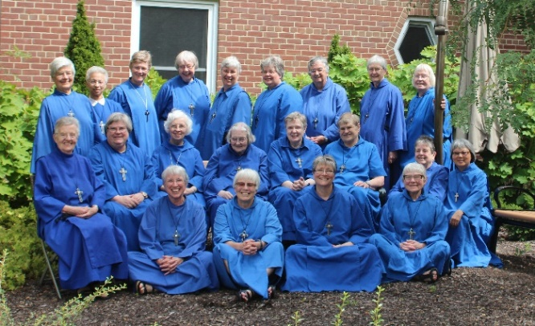
The Sisterhood of St. John the Divine is a contemporary monastic community within the Anglican Church of Canada, open to women of many denominations who join us as Sisters, Associates, Oblates, Women at a Crossroads and Companions. We were founded in Toronto in 1884 and over the past 130+ years we have tried to respond to the needs of the church and the world.

At this time in our history we put a lot of our energy into spiritual formation, retreats, and ministry to guests as well as spiritual care at St. John’s Rehab hospital and many other ministries which our Sisters carry out.

Volunteers Needed

We depend on volunteers to help with our ministry. If you can spare a few hours or more a week, if you like people and enjoy helping, please consider asking for a volunteer application. Our Volunteer Coordinator would be happy to discuss the various opportunities for volunteering. (Contact info on back.)

What Could I Do to Help?

Here are some examples of what volunteers do at the Convent:

- Staff our Reception desk, welcoming visitors, answering the phone, and helping to connect people with each other
- Greet guests and groups coming to the Guest House
- Help with mailings
- Sort donated used books which we send overseas
- Assist with filing in the Chapel
- Help to iron the Chapel linens and polish the silver
- Weed and do other gardening jobs in the summer
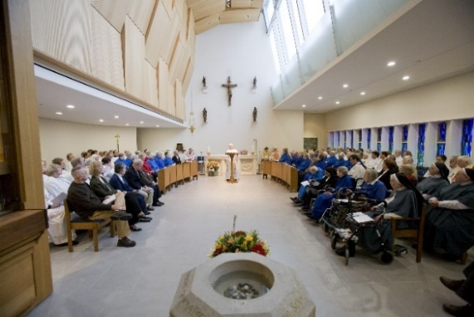
- Care for house plants
- Help with coffee breaks for guests who are in the house
- And just about anything else you can think of – if you have a special skill or gift, we can probably make creative use of it!

Benefits of Volunteering

- Volunteers share in the peace of the Convent (which can be quite busy for all its quiet atmosphere!).
- Volunteers may share in meals when they are working at the Convent.
- Volunteers meet lots of interesting people they never would have met from many ages, faith traditions, and nationalities – as well as the Sisters.
- Volunteers are welcome to use our beautiful grounds, pray the Stations of the Cross, walk the labyrinth, browse in the library and the Book Room.
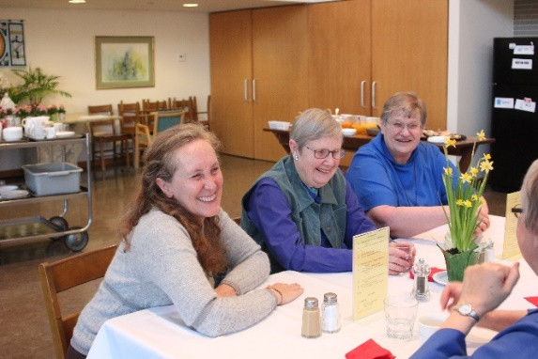
- Volunteers share in worship with the Sisters as desired (not required)

