The History of St. John’s Rehab

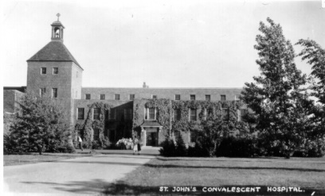

A pioneer in health care since 1885, the Sisterhood founded the first hospital in Ontario focussing on convalescence and rehabilitation in 1936. It was a field not then recognized as a necessary health service by the government. With the help of a Board of Directors, and the support of the general hospitals in Toronto, convalescent care was recognized and became a funded part of the hospital and health care system. A site was chosen and construction started on St. John’s Convalescent Hospital.

The site on Cummer Avenue was 25 acres of farm land and golf course. It was a barren expanse of land until the original Sisters-Beatrice, Emily, Angela and Vera- began to lay out gardens following the plan of a landscape gardener. Sr. Emily, who had completed a course at the Guelph Agricultural College, obtained seedlings from the Ontario Department of Lands and Forests, and with the help of George Lockyer, the original gardener, planted 7,000 trees along the property, as well as shrubs, and the rose garden to the south of the hospital.

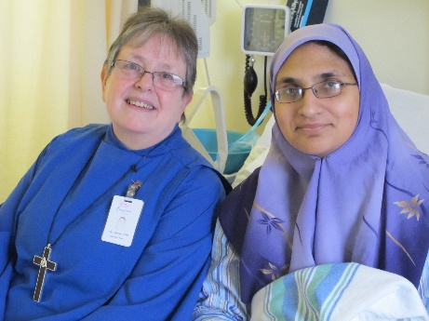
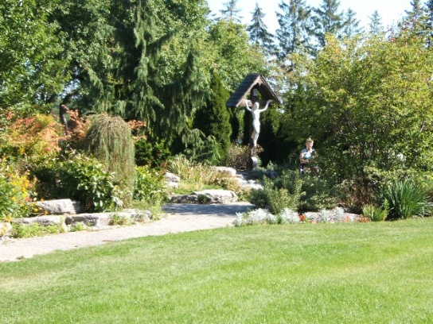

In 1936, Governor General, Lord Tweedsmuir, opened the 64-bed hospital.
Today, the grounds of the hospital reflect the care and vision of these early sisters and their understanding of the impact of surroundings in a holistic approach to healing. In 2012 St. John’s Rehab Hospital and Sunnybrook Health Sciences Centre became a single health care provider from acute care to recovery.

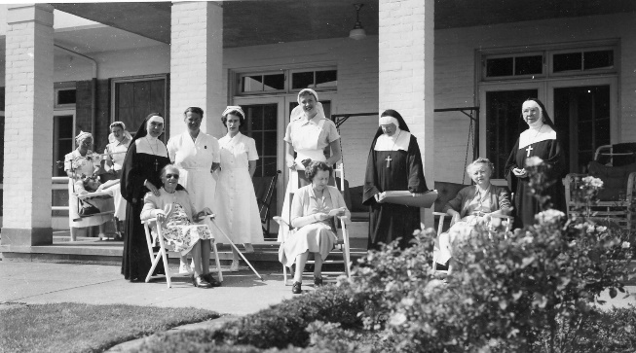

The Sisters’ Mission at SJRH

The Sisters promote a multi-faith, multi-cultural approach to health care that emphasizes the dignity of individual patients.

As a praying community in the midst of the active work of the Hospital, we advocate for a vision of health care which expresses the Sisters’ mission and values in a multi-faith, multi-cultural setting, and we provide spiritual and pastoral support for all who desire it.

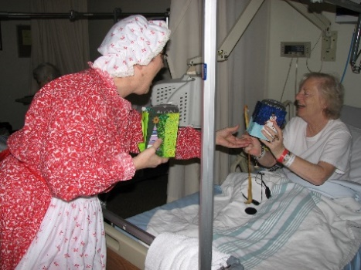

The Sisters, the Chaplain, and many volunteers associated with the Sisters are the Spiritual Care team at St. John’s Rehab. The Sisters are the spiritual care providers, visiting patients and giving listening and caring support. They are members of the multi-disciplinary team on each inpatient floor.

The chapel at St. John’s is always open for all patients, staff, visitors and volunteers. There are regular services offered in the chapel each week – an ecumenical Morning Prayer service on Sundays, and an Anglican Eucharist on Wednesday afternoons. Roman Catholic communion is offered weekly, and visitors from other faith traditions come regularly as well ..
St. John’s Rehab Vision and Values

St. John’s site of Sunnybrook Health Sciences Centre continues the proud tradition of the founding Sisters, with a holistic approach to treating body, mind, and spirit, focussed on:

- A community of support built on trust, mutual respect, integrity, teamwork and partnerships

- Compassionate care centred on empathy and responsiveness

- Personal and corporate accountability for all our actions

- A spirit of learning that contributes new knowledge and skills to continuously improve practice and service

- Communication that is interactive, informative, open, honest and respectful.

St. John’s Rehab is Ontario’s only hospital solely dedicated to specialized rehabilitation. Home to Canada’s only organ transplant rehab program, and the only burn rehab program in Ontario, St. John’s develops individually customized care for people with complex life-changing illnesses and injuries, such as amputations, cancer, cardiovascular surgery, orthopaedic conditions, strokes, neurological conditions, traumatic injuries and other complex medical conditions and procedures.
St. John’s Rehab is moving to the forefront of specialized rehabilitation with innovative research, learning and teaching. With a unique focus on the whole person – body, mind, and spirit – St. John’s Rehab is rebuilding people’s lives.

For more information about volunteering at SJR, or to reach the SJR Chaplin, please email:

The Reverend Canon Joanne Davies at

joanne.davies@sunnybrook.ca

The Sisters of St. John the Divine engage in a number of other ministries, including the Convent Guest House next door to the hospital, which welcomes family members or friends of out-of-town patients. For information, please contact:

ST. JOHN’S CONVENT GUEST HOUSE

233 Cummer Avenue
Toronto, ON M2M 2E8
416-226-2201 ext. 305
guesthouse@ssjd.ca
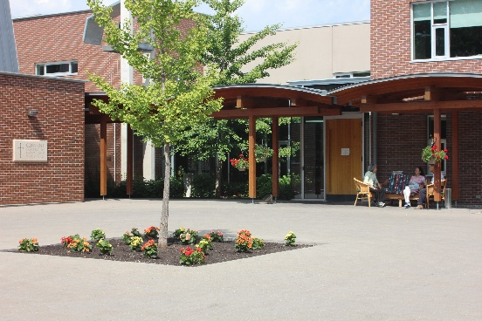

The Sisterhood of St. John the Divine is a registered charity. Our charitable donation number is BN 119254266 RR0001.

St. John’s Rehab

A Site of the Sunnybrook Health Sciences Centre
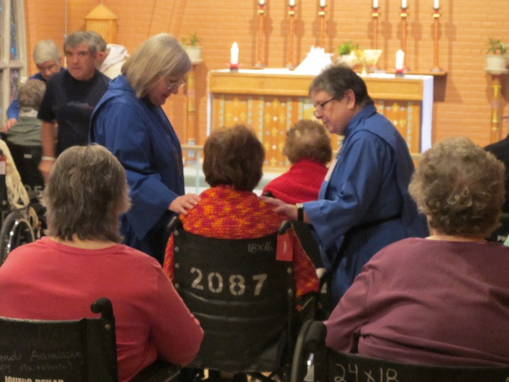

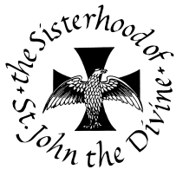

A Monastic Community within the
Anglican Church of Canada

