Chastity

The vow of chastity is grounded in the wholeness of love with which Jesus embraced humanity and all creation. It is a way of releasing all our energies for total commitment to Christ, a wholeness in love which is creative and demands integrity and purity of life.

Obedience

The vow of obedience is grounded in the singleness of purpose with which Jesus lived in order to accomplish the will of the One who sent him. It is the loving and voluntary response of the mature and free creature, making us available to God for God’s glory.

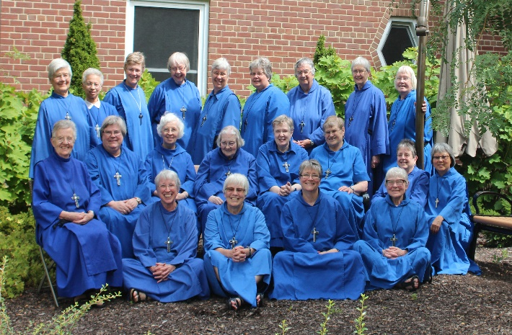
Is A Call to the Monastic Life for You?
-Are you open to new challenges?
-Do you want to make a difference in the lives of others?
-Do you desire to serve God with all your heart, soul, mind and strength?
-Would you like to live in intentional community?
Women who would like to inquire further should be:

- Between the ages of 25 and 55

- A baptized Christian of any denomination

- In good physical and mental health

- Free of debt and without dependent children

- Willing to follow Jesus in the way of self-giving love.

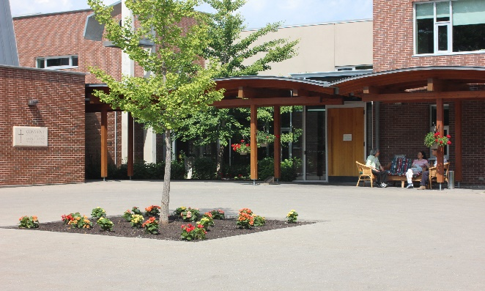
If you are interested to learn more, please contact

St. John’s Convent
233 Cummer Avenue
Toronto, ON M2M 2E8

Tel: 416-226-2201
Fax: 416-226-2131
E-Mail: convent@ssjd.ca
www.ssjd.ca
www.facebook.com/ssjdcanada
www.twitter.com/ssjdcanada

The Sisterhood of St. John the Divine is a registered charity. Our charitable donation number is BN 11925 4266 RR0001.
Love,
Prayer
&
Service

A radical call to follow Jesus
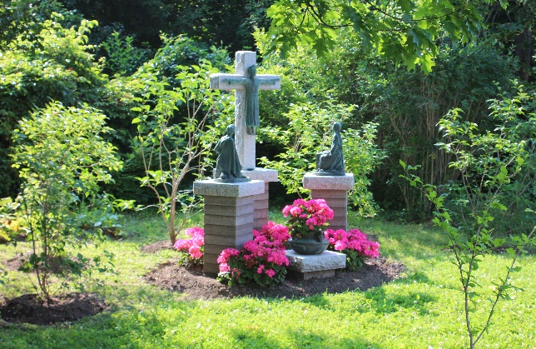
Discerning a Vocation to
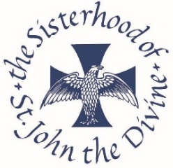

A monastic community within the Anglican Church of
Canada.

The word “vocation” comes from the verb “vocare” meaning to call. God calls us all to a variety of vocations within vocations. Discerning or figuring out the one for you can be both exciting and challenging.

At SSJD, our life is rooted in prayer out of which flows our ministries of

- Corporate prayer, music and worship

- Preaching, leading retreats and quiet days

- Hospitality through our guest house

- Spiritual direction and pastoral care

- Study and education

- Many other hidden ministries

Discerning a Religious Vocation

A call to the religious life needs to be carefully and
prayerfully discerned within the body of Christ. This happens both within the Community you feel attracted to and within your personal communities of family, parish, Bible-study or prayer groups. It also happens through conversations with your priest or spiritual guide.

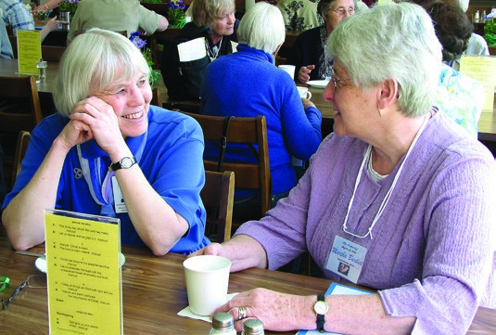
The Sisterhood of St. John the Divine offers a four-week discernment program each summer called “Women at a Crossroads” for women who are exploring new directions in ministry.

We also offer an individualized discernment program for anyone who is specifically interested in exploring the religious life.

Both programs help you experience the life of the Sisters through opportunities to share our life of prayer, work, study and relaxation. There are classes on prayer and discernment as
well as individual mentoring with a Sister.

Joining the Community: Beginning the Journey to become a Sister of St. John the Divine

Postulancy
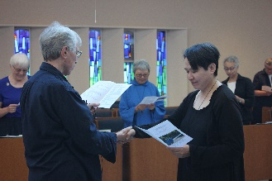

If you believe that God may be calling you to learn more about the religious life, you may apply to be admitted as a Postulant (from the Latin word for “seeker”). You can only discern a vocation to a monastic community by actually trying it out. As a postulant you promise to be as open as possible to the guidance of the Holy Spirit as you and the community together discern how God might be calling you.
After six months as a postulant, if you and the Community agree that it is time to take the next step, you enter the three -year Novitiate and receive the habit of the Community.

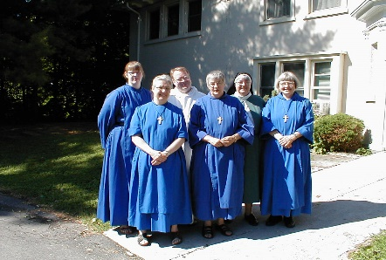
Novitiate

As a novice, you promise to be faithful to the SSJD Rule of Life. However, you are free to leave at any time during the three years of the novitiate. Postulants and novices participate fully in the life of the Community. They also have time set aside for study and regular visits with the Novitiate Director for individual mentoring and help in discerning God’s will for their lives. They meet regularly with a spiritual director, as well.

The Vows
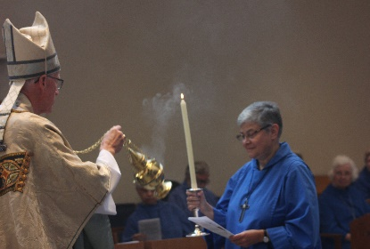

After three years as a novice, if both you and the Community agree that you have a vocation to the monastic life as lived out in SSJD, you then make your “First Profession” in which you promise to observe the vows of poverty, chastity, and obedience for three years. At the end of that time, if you and the Community again discern it is God’s will for you to take the next step, you make your “Life Profession” to live in observance of the vows for the rest of your life.
The traditional monostatic vows of Poverty, Chastity and Obedience are a specific way of living out the baptismal covenant of all Christians.

Poverty

The vow of poverty is grounded in the simplicity of life which Jesus lived and taught, and manifests itself in contentment, simplicity of living and joyful dependence on God. It requires us to use with reverence, responsibility and generosity all that God entrusts to us.

