“As I walk through the doors of the Convent, it is like coming home. That sense of comfort and connectedness never ceases to amaze me. I treasure the silence, am nourished by the worship and rest in the Spirit, which is so obviously present.” –a Guest
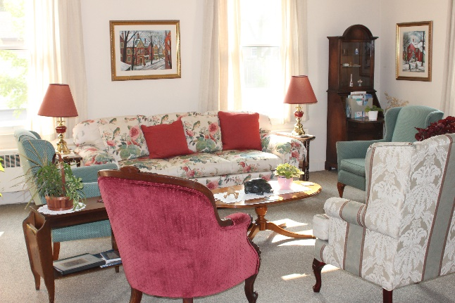

The Comforts of Home

On retreat, but still need to check your messages? We understand. WIFI is available throughout the Guest House.

Feel like a cup of tea or a late-night snack? No problem! Individual guests may use our self-catering pantries, available on each floor.

Bring Your Group

Our meeting rooms accommodate groups from 5 to 40 people. Smaller breakout and interview rooms are also available. Groups may provide their own leadership or request a sister to lead a retreat or workshop.
St. John’s Guest House is a welcoming place for:
“Our congregation’s first weekend at the convent was a turn-around moment in the life of our church. The intentional prayer life, comfortable silence, and kind attentiveness of the Sisters served as a model for our own community of how to go beyond doing things together and simply ‘being’ together. We look forward to making it an annual event!”
– a Pastor
- congregational retreats
- parish and diocesan committees
- staff days; study groups; prayer circles
- youth groups; confirmation classes

Why not bring your group?

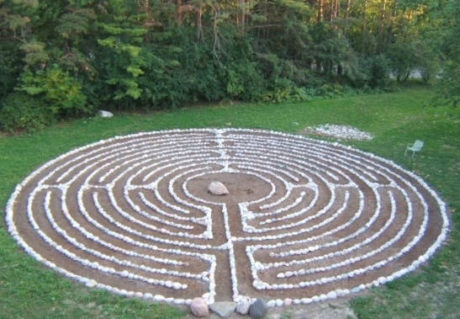
“Thank you Sisters, for the silence, for your gift of music, for the loveliness of your spacious grounds, and for the atmosphere of kindness – even your kitchen folks’ ideas of what-to-do-with tofu!” – a Guest

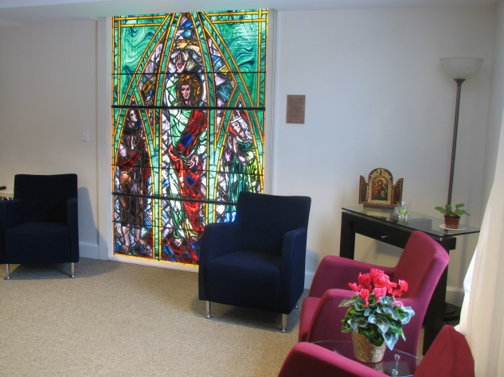
Location

St. John’s Convent is located in a quiet urban area of North Toronto adjacent to 25 acres of parkland that guests are free to enjoy. We are easily accessible from the airport via major highways, and from downtown Toronto via public transit. While we have ample parking, we encourage ecological responsibility in the use of public transit and car-pooling when possible.
For information about Retreats, Quiet Days and Fees, please contact us at:

https://ssjd.ca

St. John’s Convent Guest House
233 Cummer Avenue
Toronto, Ontario, M2M 2E8

Phone: 416-226-2201 ext. 305
Email: guesthouse@ssjd.ca

www.facebook.com/ssjdcanada
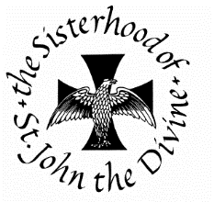
www.twitter.com/ssjdcanada
A Monastic Community within the
Anglican Church of Canada

A HOME FOR THE HEART

St. John’s Convent
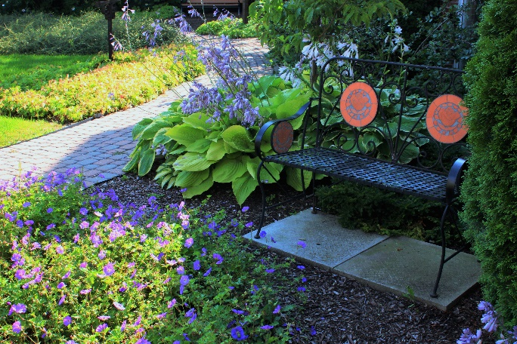
Guest House

Welcome to this sacred space,
Where you will find
Gentle hospitality,
Comfortable accommodation
And food for your soul in an atmosphere of
transformative stillness.

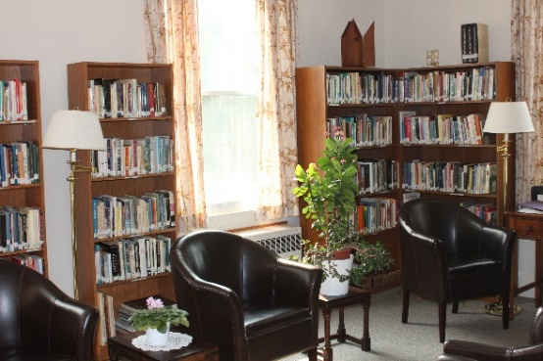
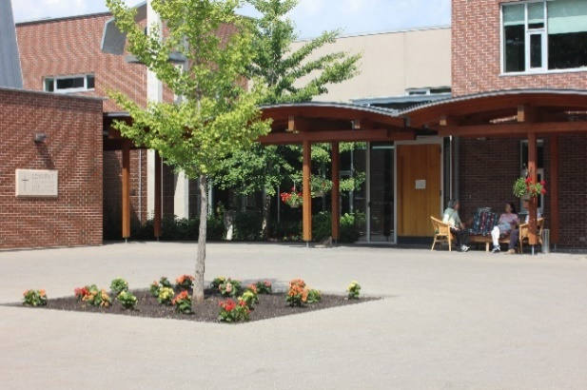
Rest, Renew, Reflect

In an increasingly noisy and hectic world,
our Guest House is a quiet place apart, where people from all over Canada and beyond come to pray, meditate and find spiritual nurture. We can help you reconnect with your self, with others and with God in a variety of ways:
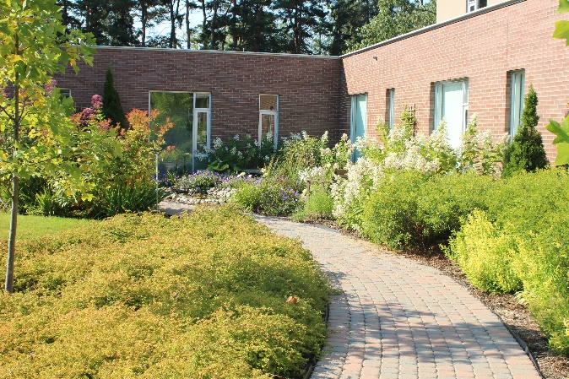
- informal personal retreats
- formal retreats with spiritual direction
- group retreats and quiet days
- spirituality workshops and parish programs
- a labyrinth for walking meditation
- share in the Sisters’ daily chapel services
- tours of the convent and presentations on Anglican religious life
- reading and devotional materials
- safe overnight accommodation
- comfortable, well-equipped meeting rooms
- individualized sabbatical programs

All our facilities are wheel-chair accessible and we make every effort to accommodate any special needs our guests may have. While the Sisterhood is an Anglican monastic community, we welcome women and men from all spiritual traditions and those with no religious affiliation.

Food for the Soul

Throughout the year, the Sisterhood offers a program of retreats and quiet days covering a variety of themes. As its name suggests, “Food for the Soul” is designed to feed the hungry spirit, while encouraging growth, healing and wholeness.

Retreats may last two or more days, beginning with Evening Prayer at 5 pm on the first day and ending with Holy Eucharist and a midday meal on the last day. Numbers may be limited so it’s good to register early.

Quiet Saturdays are day retreats which begin with refreshments at 9:30 am and end at 4 pm. The leader will give 2–3 talks during the day with time for personal reflection and to join the Sisters for the mid-day Eucharist.

Visit our website for our schedule of upcoming conducted retreats and quiet Saturdays or contact the Guest House for more information.

Be Our Guest
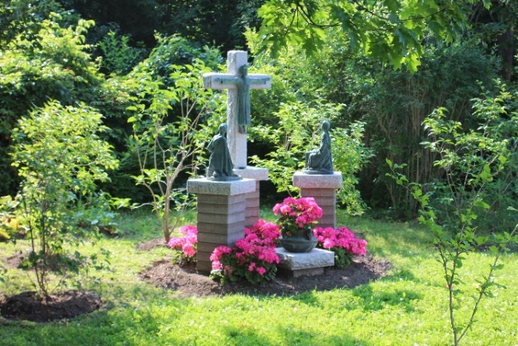

Many people long for a day (or a few days!) away from the stress of life in our over-crowded, over-noisy, and over-busy culture. Come and enjoy some sacred time apart, alone, with a friend, or a group.

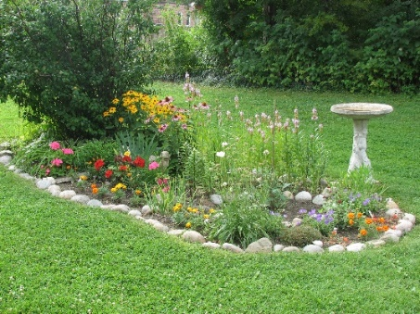
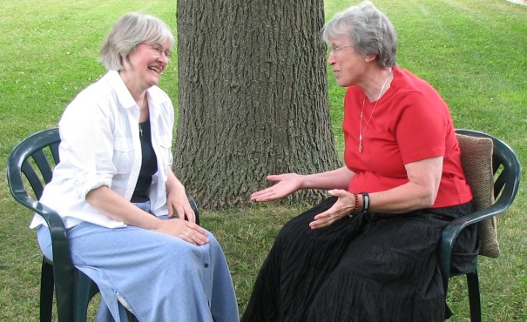

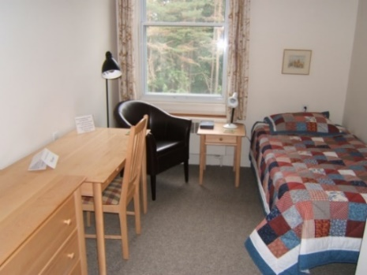
Simply but comfortably furnished, our 32 single rooms and four double rooms offer peaceful sanctuary to a maximum of 40 people. Double rooms have en-suite baths. Single rooms share large washroom and shower room facilities on each floor.

Most meals are silent and eaten in the Sisters’ Refectory. We try to accommodate our guests’ dietary concerns.

We maintain a spirit of silence throughout the Guest House, with space designated for use of cell phones and other conversations.

We are also concerned for the health of our guests, so we maintain a smoke-free and alcohol-free environment. (Alcohol may be served at some group functions with prior consent of the Sisters). As far as possible, we limit use of scented products and ask guests not to use perfumed products in the Guest House.

