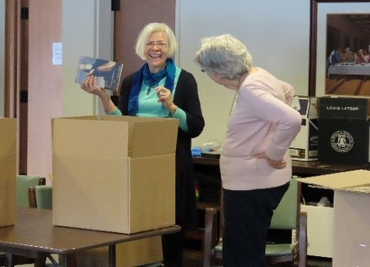

The

Associates

of the

Sisterhood of St. John the Divine

“So then you are no longer strangers and sojourners, but you are fellow citizens

with the saints, and members of the household of God.”

Ephesians 2:19

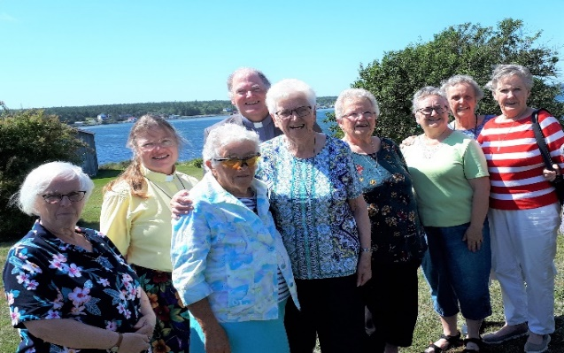

# PRAYER FOR ASSOCIATES

Almighty God, Ruler and Sustainer of the whole earth, who called your servant St. John to the vision of heaven and the life of love, grant that the Associates of the Sisterhood of Saint John the Divine may grow daily in the spirit of prayer and love. May they be ever renewed in the power of your Holy Spirit and enabled to serve you generously in whatever you give them to do; through Jesus Christ our Saviour. Amen.

# 

# If you are interested to learn more,

# please contact

# 

# ST. JOHN'S CONVENT

Attn. Director of Associates

233 Cummer Avenue

Toronto, ON M2M 2E8

TEL: 416-226-2201

FAX: 416-226-2131

E-Mail: [convent@ssjd.ca](mailto:convent@ssjd.ca)

___________________________

[*www.ssjd.ca*](http://www.ssjd.ca)

[*www.facebook.com/ssjdcanada*](http://www.facebook.com/ssjdcanada)

*www.twitter.com/ssjdcanada*

The Sisterhood of St. John the Divine is a registered charity. Our charitable donation number is BN 11925

Join the Sisters as part of an extended family following Jesus in a life of love, prayer, and service.

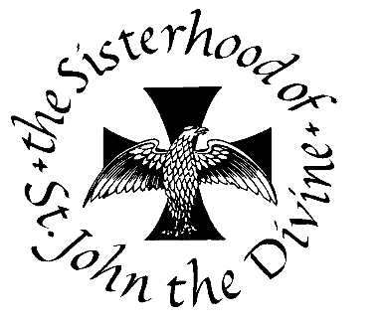

A Monastic Community within the Anglican Church of Canada

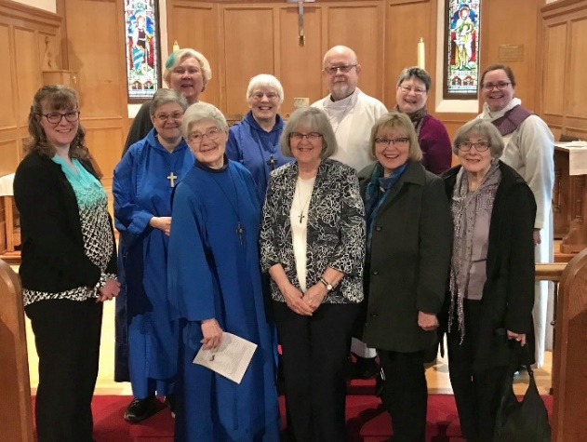

The Associates of the Sisterhood of St. John the Divine are men and women, lay and ordained, who are members of a Christian parish community and seek to deepen their life in Christ through following a Rule of Life in association with the Sisters. In other words, they are ordinary people who are seeking “something more” in their spiritual life and believe they can be nurtured in their spiritual journey through being connected with the life and ministry of a monastic community.

The Sisterhood of St. John the Divine, was founded in 1884. It owes its founding to the vision and dedication of a group of women and men who prayed and worked for a monastic community to be established in Canada—where the life of Christians could be nurtured and strengthened.

## THE RULE FOR ASSOCIATES

1. To become informed, and to be willing to tell others, about the overall principles of the Monastic Life, and in particular about the life and work of the Sisters of Saint John the Divine.
2. To be an active member of a worshipping congregation within the Christian faith, and when possible, to share in the Eucharist on Sundays and on Major Feasts. To pray especially for the Sisterhood of Saint John the Divine on their four major anniversaries: February 9 (Hannah Grier Coome, Founder, SSJD), May 6 (Feast of St. John), September 8 (the Nativity of the Blessed Virgin Mary and the Foundation Day of SSJD), December 27 (Feast of St. John the Evangelist).
3. To include in one’s daily intercessory prayer the Community and Associates.
4. To seek to grow in prayer, for renewal of life in Christ, by spending time daily in some form of listening prayer, often called meditative or contemplative prayer.
5. To seek to live an intentional Christian life with thoughtfulness and integrity, preferably with the help of a spiritual director/ companion or soul friend.
6. To read some portion of Holy Scripture daily, and to read books helpful to growing in the Christian life.
7. To make an annual Retreat of at least two days whenever possible or to have/participate in two or more Quiet Days annually.
8. If called upon, to be willing to help the Community, and to help Associates who live in their vicinity. As they are able, Associates contribute financially to the Sisterhood.
9. To report yearly through a reflective letter or to visit with the Director of Associates within the month of the Anniversary of their Admission as to the value of the keeping of this Rule.

The Rule for Associates is intended to provide a framework for the journey of faith, a trellis to support you in your own life and ministry of love in and for the world.

**TO BECOME AN ASSOCIATE**

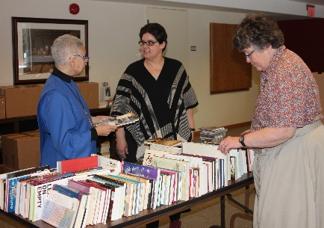

If you are interested in learning more about the Associates, or are interested in applying, please write, phone or e-mail the Director of Associates at the Convent to request further information about becoming an Associate. Contact information is on the back of this brochure.